

**Experiment No. 9**

**Title:** Study Experiment on Internationalization and Localization

# Batch: A3 Roll No.: 16010421073 Experiment No.:9

**Aim: Case Study on Internationalization and localization**

**Resources needed:** Web Browser

# Pre Lab/ Prior Concepts:

Students should have prior knowledge of HTML/CSS/Basic Programming, web services.

# Theory:

**Internationalization (i18n)** is the process of designing and developing software or products that can be adapted to different languages and cultures, while **localization (l10n**) is the process of adapting a product or content for a specific locale or market.

Internationalization involves designing products with language and cultural differences in mind, such as using Unicode character encoding, avoiding hard-coded text, and leaving enough space for text expansion.

Localization involves translating, adapting, and customizing a product to meet the specific linguistic, cultural, and regulatory requirements of a particular market, such as using local date and time formats, currencies, and units of measurement.

Internationalization is usually done first, before localization, as it lays the foundation for adapting a product to different languages and cultures. Internationalization and localization are important for businesses that want to expand their reach globally, as they allow companies to provide a more personalized and relevant experience to their customers in different regions.

# Internationalization (i18n) Example

Let’s say you’re internationalizing the dashboard of a software application, and you need to set up the keys for a welcome message. For now, the software will be sold in English and Spanish.

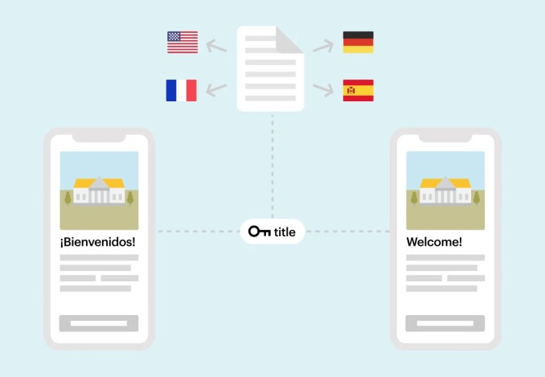

Instead of coding the software for each specific language, the internationalization process replaces that code with keys — this not only makes for easy localization, but it also neutralizes the code and adapts it for various languages you may introduce in the future.

# Localization example

Let’s take the example of localizing a product for the Arabic market. Arabic is a right-to-left (RTL) language, which means that not only do you need to translate the content, you also need to re-design the interface.

While localizing your product for Arabic, you discover your internationalization team failed to implement the correct code to allow for both left-to-right (LTR) and RTL designs. Making it impossible to correctly display RTL text.

Developers will need to allocate additional resources and time to correct the issue, resulting in delays to the product release.

When engineering teams know that word order changes, page direction is reversed, and special characters have to be handled differently in some languages, they are able to internationalize code the right way from the get-go, making localization a lot smoother.

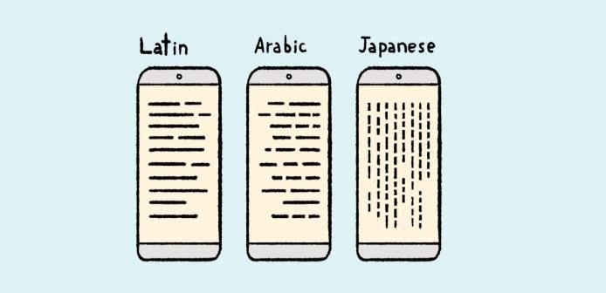

Activity:

**1. Prepare a report on Internationalization and Localization**

**Report**

**Title: Internationalization and Localization: A Comprehensive Report**

1. **Executive Summary**

Internationalization and localization are two critical concepts in the realm of software and content development. Internationalization involves designing products or content that can be adapted for global markets, whereas localization is the process of customizing these products or content to meet the specific cultural, linguistic, and technical requirements of a target market. This report explores the importance, benefits, and best practices of internationalization and localization in a globalized world.

1. **Introduction**

In today's interconnected world, businesses and organizations increasingly target international markets. Internationalization and localization are essential strategies for reaching a diverse global audience effectively. Understanding these concepts is crucial for achieving success in a competitive global marketplace.

* **Internationalization (I18n)**

**1. Definition**

Internationalization (often abbreviated as I18n) is the process of designing and developing products or content in a way that makes them adaptable for different regions and languages without changing the core code or content structure.

**2. Importance**

Internationalization enables a product or content to be easily adapted for multiple regions, which can lead to expanded market reach and increased revenue. It simplifies the process of localization by separating content from code, making it more efficient and cost-effective.

**3. Best Practices**

**a.** Use Unicode and UTF-8 encoding for text to support multiple languages.

**b.** Ensure that the software can handle various date, time, and number formats.

**c.** Implement flexible layouts that accommodate longer or shorter text strings.

**d.** Separate content from code to facilitate easy localization.

* **Localization (L10n)**

**1. Definition**

Localization (often abbreviated as L10n) is the process of adapting products or content to suit the linguistic, cultural, and technical requirements of a specific target market. This involves translating text, adapting graphics, and addressing regional preferences.

**2. Importance**

Localization is crucial for creating a personalized and culturally relevant user experience. It helps businesses build trust with users in different markets by showing respect for their language and culture.

**3. Best Practices**

**a.** Collaborate with native speakers or professional translators for accurate translations. **b.** Customize graphics, symbols, and images to align with local preferences.

**c.** Consider local legal and regulatory requirements for content.

**d.** Test the localized version for linguistic accuracy and cultural relevance.

1. **Benefits of Internationalization and Localization**
   1. **Increased Market Reach**

By making products and content accessible to a global audience, internationalization and localization can significantly expand market reach, potentially leading to increased sales and revenue.

* 1. **Improved User Experience**

Localizing content and products creates a more user-friendly and engaging experience for customers in various regions, increasing customer satisfaction and loyalty.

* 1. **Competitive Advantage**

Companies that invest in internationalization and localization gain a competitive advantage by effectively reaching untapped markets and establishing a stronger global presence.

1. **Challenges and Considerations**

**4.1. Cultural Sensitivity**

Avoiding cultural insensitivity and misunderstandings is crucial when localizing content, as missteps can damage a company's reputation.

**4.2. Cost and Resources**

Internationalization and localization can be resource-intensive, involving translation costs, testing, and ongoing maintenance. Organizations should carefully budget for these expenses.

**4.3. Quality Control**

Ensuring the quality and accuracy of translations and adaptations is a significant challenge, as poor localization can lead to user dissatisfaction.

1. **Conclusion**

In a globalized world, internationalization and localization are key strategies for businesses and organizations seeking to expand their reach and connect with diverse audiences. By following best practices and recognizing the importance of cultural sensitivity, companies can effectively bridge linguistic and cultural gaps, gaining a competitive edge in the international marketplace.

KJS



CE/IT/TYBTECH/SEMV/WP-II/2023-24

**Questions:-**

1. What is the difference between internationalization and localization in Web application?
2. When should I use internationalization vs. localization?

**Ans 1:**

|  |  |  |
| --- | --- | --- |
| **Aspect** | **Internationalization** | **Localization** |
| **Definition** | * Designing and developing a web application to be adaptable to different languages and cultures without changing the source code. | * Adapting a web application to a specific language or region by providing translated content and culture-specific formats. |
| **Focus** | * General, making the application ready for multiple languages and regions. | * Specific, tailoring the application to a particular language or region. |
| **Scope** | * Global, covering all aspects of the application that might vary between languages/cultures. | * Local, addressing only the specific language and culture-related components. |
| **Primary Goal** | * To separate content and code, making it possible to switch between languages and regions without code modifications. | * To provide a localized experience for users in a specific language or region. |
| **Components Affected** | * Mainly code structure and architecture, enabling language and culture-specific content to be loaded dynamically. | * Content, such as text, images, dates, numbers, currency, and other culture-specific elements. |
| **Tools** | * Language files, resource bundles, and libraries for handling content and formats. | * Translation files, date/time formatting, number formatting, and locale settings. |
| **Implementation** | * Implement i18n once at the application's core, then l10n is done for each language/region separately. | * Implement l10n separately for each language or region, after i18n has been established. |
| **Example** | * Creating a system where text strings and content can be loaded based on the user's language preference. | * Translating the text in the application, changing date formats, and formatting numbers according to a specific locale. |

**Ans 2:**

1. **Internationalization :**

Use internationalization when your goal is to make your web application adaptable to multiple languages and regions. You should consider i18n in the following scenarios:

* **Global Audience:** If you intend to reach a global audience and want your application to be accessible in multiple languages and regions.
* **Scalability:** When you want to future-proof your application, allowing for the addition of new languages without significant code changes.
* **Content Separation:** When you want to separate content from code to maintain a single codebase and reduce duplication.

1. **Localization :**

Use localization when you want to tailor your web application to a specific language or region. You should consider l10n in the following scenarios:

* **Specific Audience:** If you have a significant user base in a particular country or region and want to provide them with a customized user experience.
* **Culture-Specific Elements:** When you need to address language-specific content, such as text translations, date and time formats, number formatting, and currency symbols.
* **User Engagement:** When you want to improve user engagement and user understanding by presenting content in the user's native language and adhering to their cultural expectations.

KJSCE/IT/TYBTECH/SEMV/WP-II/2023-24

# Outcomes:

# CO 4: Demonstrate the use advanced features such as REST API, email handling, localization and internationalization in PHP.

**Conclusion: (Conclusion to be based on the objectives and outcomes achieved)**

**Thus we successfully did a case study on internalization and localization.**



**Grade: AA / AB / BB / BC / CC / CD /DD**

**Signature of faculty in-charge with date**

**References:**

1. <https://docs.oracle.com/cd/E19879-01/819-3669/bnaxu/index.html>
2. [https://lokalise.com/blog/internationalization-vs-](https://lokalise.com/blog/internationalization-vs-localization/#%3A~%3Atext%3DInternationalization%20(i18n)%20is%20the%20process%2Ca%20specific%20locale%20or%20market) [localization/#:~:text=Internationalization%20(i18n)%20is%20the%20process,a%20specific%20loca](https://lokalise.com/blog/internationalization-vs-localization/#%3A~%3Atext%3DInternationalization%20(i18n)%20is%20the%20process%2Ca%20specific%20locale%20or%20market) [le%20or%20market.](https://lokalise.com/blog/internationalization-vs-localization/#%3A~%3Atext%3DInternationalization%20(i18n)%20is%20the%20process%2Ca%20specific%20locale%20or%20market)

# Books:

1. Thomson PHP and MySQL Web Development Addison-Wesley Professional, 5th Edition 2016.
2. Peter MacIntyre, Kevin Tatroe Programming PHP O'Reilly Media, Inc, 4th Edition 2020
3. Frank M. Kromann Beginning PHP and MySQL: From Novice to Professional, Apress 1st Edition, 2018